PRESS RELEASE
Media Contact: Meg Koch

Virginia Thurston Healing Garden Cancer Support Center

Member of Massachusetts Department of Public Health
Massachusetts Comprehensive Cancer Prevention and Control Network (MCCPCN)

Executive Director
(978) 456-3532
Margaret@HealingGardenSupport.org
____________________________________________________________________________________
FOR IMMEDIATE RELEASE (IMAGES ATTACHED): “BostonCancerSupport.org” , “ Cancer Survivor (jpeg)

The MA Comprehensive Cancer Prevention and Control Network
Announce Covid-19 Resources Specific to Cancer Survivors

Figure 1
BostonCancerSupport.org
Photo credit to Susan Chaityn Lebovits
Harvard, MA (June 1, 2020) – Cancer survivors are among the high-risk populations should they contract the Covid-19 virus. Many have comorbidities such as heart, kidney, lung and liver compromises, as well as immunosuppression that results from their cancer treatments. Increased levels of anxiety and fear, and financial toxicity from medical expenses will be further exacerbated by the secondary Pandemic effects of pay-cuts, and furloughs.

The Massachusetts Comprehensive Cancer Prevention and Control Network, a workgroup under the direction of the MA Department of Public Health, has curated a portal of resources to assist all Massachusetts survivors that include State and National Agencies, Financial Resources, Emotional Health, Physical Fitness as well as Food Assistance resources. The website, Https://BostonCancerSupport.org is updated daily.

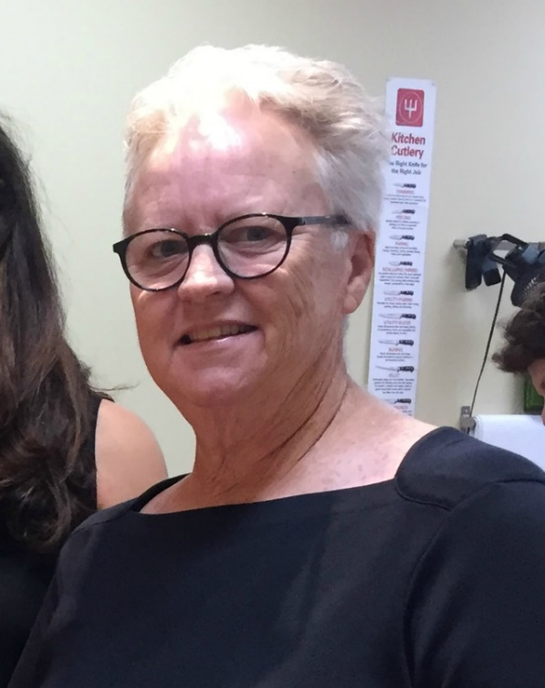
“We have seen a tremendous uptake in needs in the cancer community. For some, their regular medical care is being interrupted due to the need for social distancing, if they are getting care they must go alone, finances are running out and worry is high, so these resources will be so welcome”, says Meg Koch, MCCPCN member, and Executive Director of the Virginia Thurston Healing Garden Cancer Support Center in Harvard, MA.
Carol Bell, Arlington, MA Cancer Survivor
Photo credit Maddie Phadke
“I had no idea there was so much support out there. I feel like I have found an oasis in the desert”, confides Healing Garden client, MA cancer survivor.
----------------------------------------------------------------------------------------------------------
About the Healing Garden
Medical care focuses on a curative treatment plan, and our services are supportive of that care. The Healing Garden Cancer Support Center provides high quality, evidence-based therapies in a healing environment, located on eight acres of lovingly created gardens on a wooded hillside in Harvard, Massachusetts. Here, without reminders of the disease and medical interventions, clients can begin treatments feeling calmer and supported. Currently the Healing Garden has pivoted to offer programs and services in online forums. We offer a community of others to share in the journey, counseling and support groups, mind-body medicine for symptom management, stress reduction and restoration of wellness, education about choices that contribute to health and healing, such as nutritional education, exercise, and mindfulness, expressive therapies as an alternative to talk therapy for processing/releasing emotions, and programs and services to help regain control of life, both during and after medical treatment. For a detailed description of the various modalities of care and their contributions to healing visit Https://www.healinggardensupport.org or contact us at 978.456.3532.
About the MCCPCM
MCCPCN has a number of work groups that address strategies outlined in the state plan.
The Survivorship group is comprised of volunteers who are cancer experts, cancer survivors, or other stakeholders. Work groups evaluate data, identify gaps, formulate goals and implement projects that further the goals of the state plan.

